Critical Log

My initial concern for development of the site lay in the necessity of a mobile compatible website, with this aspect of the brief came challenges such as utilizing media queries and dynamic element sizing. These techniques proved fiddly and time consuming as I adopted a trial and error approach to correctly proportion key aspects of the site. Due to my worry in regards to the site being compatible with smaller devices, aspects like the header and footer seem disproportionately large on desktop monitors. (pictured below are examples of media queries removing images to better fit a smaller screen)

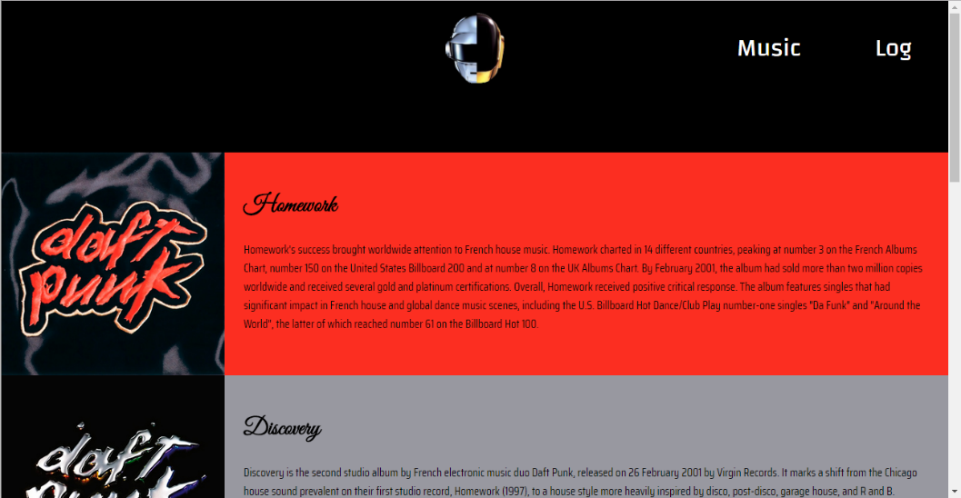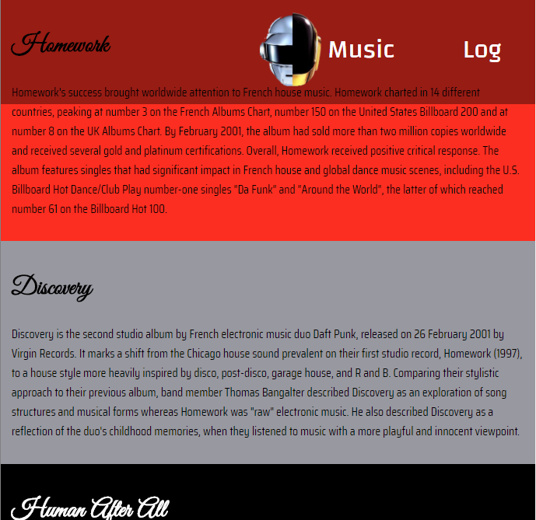

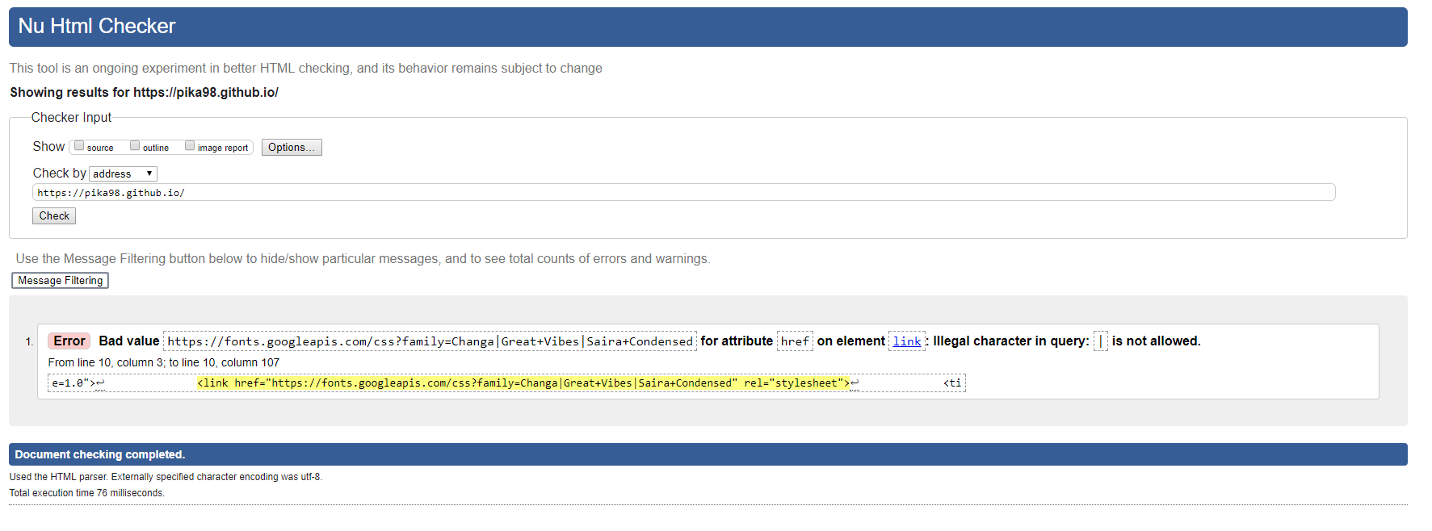Alongside this newfound importance of dynamic websites, recent years have also given way to a push in the idea of a standardised internet. Whilst HTML and CSS can be produced with a unique style depending on the author, standardisations such as w3c[1] validity checks act to ensure that code published on the web will a standardised format. Other standards like the 508 law exist in order to encourage websites to be made for those with disabilities which may impede conventional website use. In the case of my website, I had planned to strictly abide to standards from the very start of the project, this resulted in minimal error correcting upon completion and was relatively simple given the capabilities of modern programming IDEs. (pictured below is the proof of w3c validity, one unavoidable error is displayed as a result of using google fonts)

Stemming from this sense of standardisation is the idea of interoperability with HTML. Due to the multitude of web browsers now available, a single website must be built to adapt to the browser it will be viewed on. This necessity reflects itself in code as the addition of vendor-prefixed properties, that are handled by a specific browser, ie; -moz-border-radius- would be handled by Firefox. I found this process difficult in my project. Unlike my approach to coding standardisation, I did not involve these prefixes as and when they were required. As a result, going back through my code to amend sections of CSS would be a huge reverse engineering process and as a result my website is only reliably stable on Chrome, IE9 and Edge. Whilst it may be accessed on other browsers the user experience cannot be ensured, which is the key goal with the whole notion of browser interoperability. (pictured below is the website running on multiple browsers)

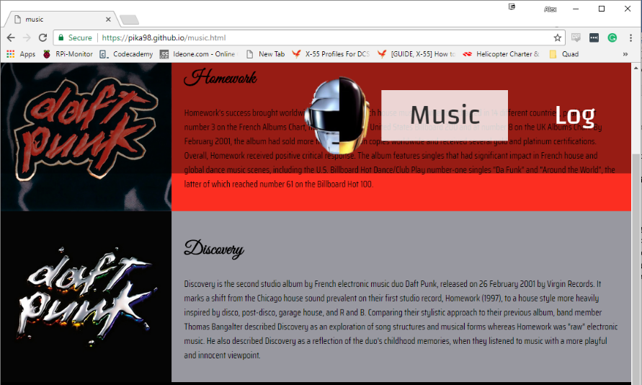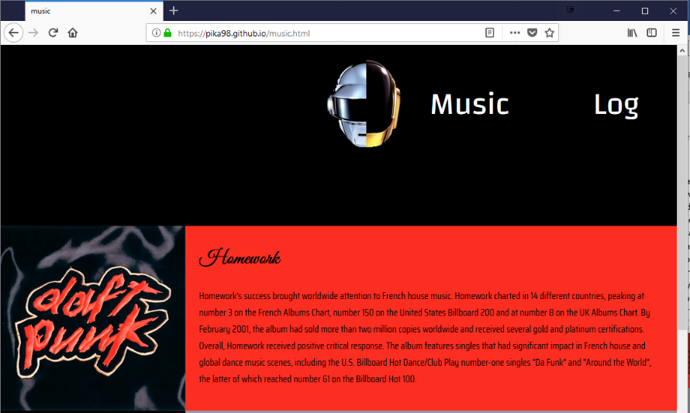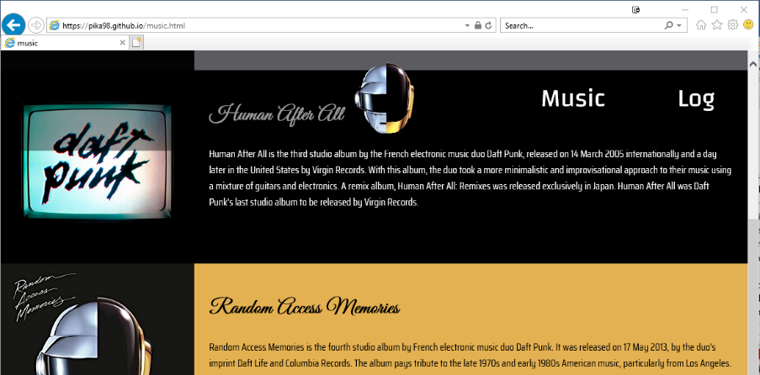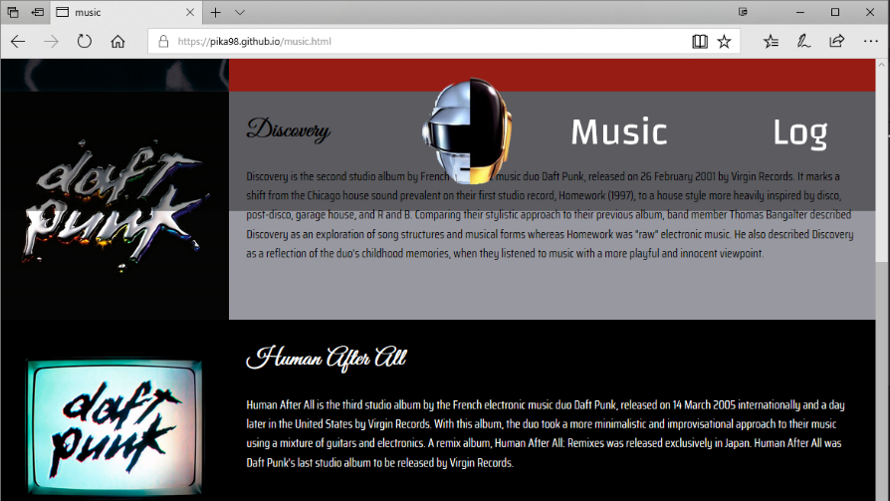

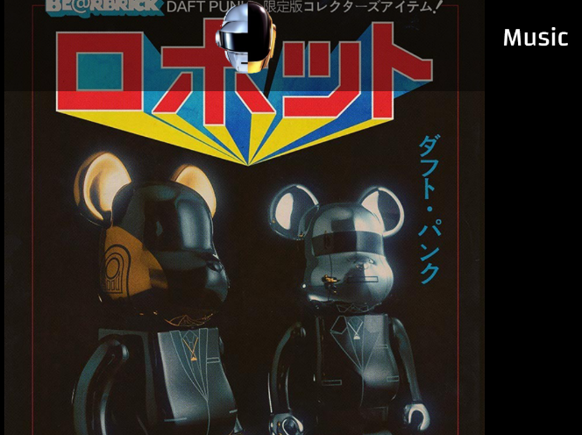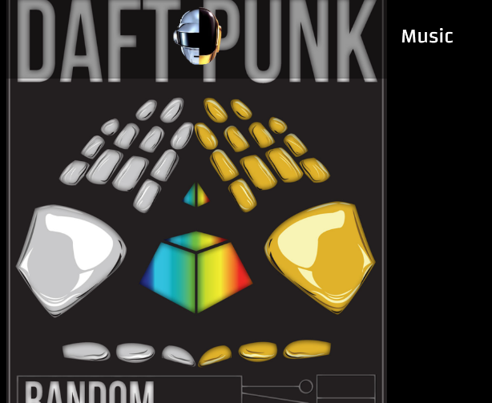My original projections of the website, looking back at the wireframe models, were very ambitious. Whilst my final website follows these aspects to a degree the complexity of my initial brief was never fulfilled. The aspects that I did retain, however, from initial conception included JavaScript poster previews, which can be seen on the index page (pictured below);

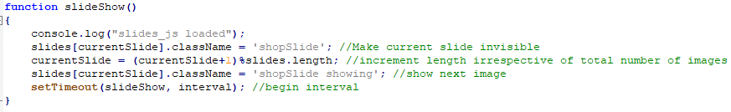This photo display was implemented using manipulation of CSS through JavaScript. By using “display:none;” as a default setting for all images, I could add a “.show class” to my desired image. This show class was attached to a variable that kept the code looping through the 5 numbers that had images assigned. This process could then be repeated on a timer to create an automatic poster carousel. In the instance I used it in it can make a good display piece to attract intrigued visitors to the website. The real daft punk website simply lists the available merchandise in vertical sprawl, so in this sense active elements encourage user engagement. (code pictured below)

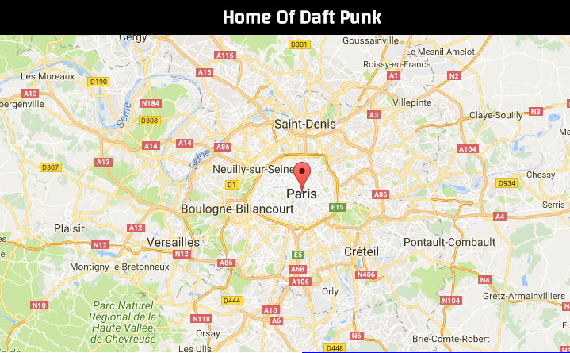Another system used to draw in user attention was the google maps API. This application programming interface allowed me to insert a live iteration of the well renowned google map directly into the webpage. The use of a map adds a direct link between the user and a point of interest and allows the user to better identify with the brand they are interacting with. This heightened level of interaction, again, it necessary in modern websites in order to attain user interest in a scene that competes for viewer attention. I chose to position the map over Paris by default, the home of Daft Punks studio.

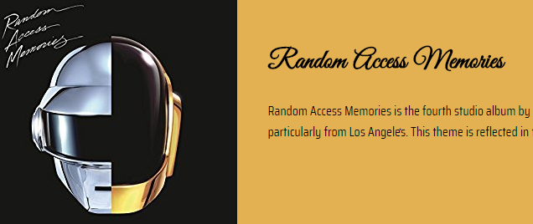In a similar way that the google API was externally linked, CSS3 allows the use of external font libraries. As a result, I could take advantage of the vast google font repository. This allowed me to use stylistic fonts that held a semantic link to Daft Punk; “Great Vibes” is reminiscent of the font on the most recent daft punk album. (pictured below is an example of google fonts)

Overall I feel that the website that I have made make use of various modern website features in order to enhance the experience of users on multiple platforms, whils abiding by standard industry practices. I feel that the compatability of the site is restrained however, and that there is a lack of HTML5 specific elements.

Alexander Cooper COO17634613 Website Link: pika98.github.io

1. World Wide Web Consortium (W3C). 2018. *World Wide Web Consortium (W3C).* [ONLINE] Available at: https://www.w3.org/